The Impact of Repeated Reading on the Reading Prosody and Reading Attitudes of Sixth Grade Students with Learning Disabilities
Brinkley Fox
East Carolina University

Abstract
The purpose of this action research study was to investigate the effects of repeated readings on the reading prosody and reading attitudes of sixth grade students with learning disabilities. This single-subject pre-test post-test design study included students within an Exceptional Children’s classroom where they received supplemental reading instruction in addition to regular reading instruction in the general classroom. Each student participated in the repeated reading intervention eight times over a span of seven weeks. Results suggest that the intervention positively impacted prosodic reading, while its impact on reading attitude was undetermined.
Keywords: Fluency, prosody, attitude, sixth graders, learning disabilities

The Impact of Repeated Reading on the Reading Prosody and Reading Attitudes of Sixth Grade Students with Learning Disabilities
According to The National Reading Panel, it is clear that fluency should not be focused solely on reading rate, but also on students’ ability to group words together into meaningful units, acknowledge punctuation, and realize where to place emphasis and where to pause to make sense of text (National Institute of Child Health and Human Development [NICHD], 2002). These elements of fluency are collectively known as prosody. Students with learning disabilities in reading often struggle with fluency, particularly with reading with prosody. Students can often maintain acceptable reading rates and accuracy, but lack prosody, or expression, in their reading. This lack of prosodic reading inhibits their ability to comprehend what they read. In addition, students that struggle with reading often have a negative attitude toward reading, while also having low-efficacy in relation to their personal reading abilities (Guthrie & Davis, 2003). As students enter middle school, struggling readers show a hasty decrease in motivation to read (Guthrie & Davis, 2003).
Instructional approaches involving repeated readings have been shown to increase overall student reading ability (Roberts, Vaughn, Fletcher, Stuebing, & Barth, 2013), and incorporating modeling into the repeated reading approach provides students with a model of fluent, prosodic reading. Practices that lead to increased fluency proficiency in terms of prosody are of importance to educators because of the close relationship that exists between overall reading fluency and comprehension (Rasinski, 2012). Success in reading comprehension is the primary goal of reading instruction, and because of the close link between prosodic reading and fluent reading, and fluent reading and comprehension, this paper seeks to present an action research proposal that explores the effects of repeated readings on prosodic reading and reading attitudes of sixth grade students with learning disabilities. A literature review that supports the research question follows.
Literature Review
Rasinski, Rikli, and Johnston (2009) shared that “if the ultimate goal of reading instruction is proficient reading comprehension, then reading fluency, both automatic word decoding and prosodic reading, needs to be part of the instruction repertoire offered to teachers and students, especially struggling readers” (p. 359). Today, there exists an overall understanding that reading fluency and reading comprehension correlate with one another, especially since the National Reading Panel’s report was introduced (NICHD, 2002). Since its publication, fluency has been considered one of the five pillars of effective reading instruction, and an increased focus on fluency in the classroom has followed.
In times past, prosody, or reading with expression, has been the “ignored bedfellow” of fluency instruction, only recently gaining more attention, although it is still vaguely defined and considered in terms of fluency instruction (Dowhower, 1991). Too often, fluency instruction is centered mainly on reading rate, or correct words per minute (CWPM). Unfortunately, the overemphasis on reading rate creates readers that learn to blow through commas, periods, and other punctuation, and are only concerned with reading fast (Marcell, 2011; Rasinkski, 2012; Rasinski et al., 2009). Educators are left with students who can fly through a given passage, but can recall very little of what they read. Prosody is the integral, missing component of fluency instruction that connects reading fluency and comprehension (Rasinski, 2012).
Rasinksi at al. (2009) found that prosodic reading was significantly associated with silent reading comprehension, which suggests that instruction aimed at improving the elements of fluency, including prosodic reading, may have a positive impact on reading comprehension. In order to read with prosody, one must avoid pausal intrusions, or inappropriate pauses within words or syntactic units, apply appropriate length of phrases, acknowledge punctuation, employ terminal intonation contours, or pitch changes, and use appropriate stress, which is the intensity in which a phoneme, syllable, or word is uttered (Dowhower, 1991). When readers do not correctly apply these elements of prosody when reading, any understanding of what is being read is seriously hindered. Prosody is described as the bridge that connects fluency and reading comprehension (Rasinski, 2012).
In the past, fluency has been an element of literacy instruction that has remained primarily in elementary classrooms; however, the National Reading Panel’s report (NICHD, 2002) posited that fluency procedures continue to be useful far beyond the primary grades. If our goal as educators is to ensure that all students are successful readers, then we must extend the goal of reading fluency beyond the elementary grades into middle school classrooms and beyond (Rasinksi, 2004). Strong correlations have been found between reading fluency and silent reading comprehension for older readers, specifically for students who exhibited high improvements in prosodic reading (Rasinski et al., 2009). At any age, comprehensive fluency instruction and practice, which includes an emphasis on prosody, can make a significant difference on the reading achievement and dispositions of all students, especially for those students who struggle with reading (Rasinski, 2012).
Repeated Readings
As previously discussed, when students read fluently, they can devote their efforts to understanding what they read rather than exerting excessive energy toward decoding the words that are on the page before them (Marchand-Martella, Martella, Modderman, Peterson, & Pan, 2013). The use of repeated readings in the classroom is one of the best tools that teachers can employ to improve reading fluency (Marchland-Martella et al., 2013). The practice of repeated readings was introduced in 1979 when Samuels compared the method of reading with participation in sporting or musical activities, in which skills must be practiced repeatedly to attain levels of success. Samuels’ (1979) influential study indicated that when students read text multiple times, their fluency increased, and their improved reading of text carried on over time when reading unfamiliar and previously unread texts. Thus, the method of repeated reading is still ever present in literacy instruction today.
The implementation of repeated readings has been shown to improve various areas of reading for students. Dowhower (1987) studied the effects of repeated readings on reading rate, accuracy, comprehension, and prosodic reading for elementary students. After seven weeks of intervention, which was carried out four to six times per week for 15 minutes, results were examined. It was found that all measured areas (reading rate, accuracy, comprehension, and prosodic reading) were significantly improved by the repeated reading intervention. Additional continued success using repeated readings has been noted throughout recent history (Mercer, Campbell, Miller, Mercer, & Lane, 2000; Morris & Gaffney, 2011; NICHD, 2002; Rasinski at al., 2009; Roberts & Vaughn, 2013; Samuels, 1979).
Although repeated readings have been implemented over time using various styles and approaches, common themes emerge as one examines the characteristics of studies that have brought about notable success: length of text to be repeatedly read by students should be kept short (approximately 50 – 200 words); text should be at students’ instructional reading levels; text should be repeatedly read by students three to four times; modeling fluent, prosodic readings of text can be incorporated and is especially useful for struggling readers; and short, frequent periods of fluency practice should be implemented on a regular basis (Allington, 1983; Joseph, 2008; Meyer & Felton, 1999; NICHD, 2002; Rasinski, 2004; Samuels, 1979). Taking these guidelines into consideration is significant in enabling educators to design effective repeated reading practices that are targeted to specifically help students improve their reading abilities.
Modeling Fluent Reading
With a focus on the element of prosody within reading fluency, one can discern the value in providing students with fluent, prosodic examples of the reading of text. When considering students who struggle with reading, providing a model reading of text is especially beneficial (Meyer & Felton, 1999). Repeated readings that incorporate modeling have been shown to be notably successful, specifically when increasing readers’ prosody is the focus.
Morris and Gaffney (2011) carried out a study that involved a struggling 8th grade student who had been identified as a non-fluent reader. An intervention was designed that included modeling of text prior to repeated readings. The intervention was implemented two days per week over the course of one year. Upon the conclusion of the intervention, the student had increased his overall reading ability just over one full grade level, whereas such progress had not been noted in subsequent years. Dowhower (1991) posited that providing students with an auditory model of fluent reading may be the most powerful of all techniques in encouraging prosodic reading. She explained that doing so provides students with examples and knowledge of what it means to read with expression. When provided with a model, students are able to explicitly hear when readers should pause and change pitch, and take note of what words or segments should be stressed or elongated (Dowhower, 1991). It was also found that students who received modeled readings of text used more appropriate phrases, exhibited less pausal intrusions, and used more appropriate pitch than students who did not receive a model (Dowhower, 1987).
Chomsky (1976) first reported success with providing students with a model of fluent reading. She shared that students’ focus needs to be shifted from individual textual work to more connected, integrated knowledge. Chomsky (1976) posited that students need support “in learning to attend to the semantics and syntax of a written passage, and in developing reliance on using contextual clues from the sentence or even longer passages as they read” (p. 289). In helping students to accomplish this, Chomsky (1976) arranged for third grade students to repeatedly listen to fluently read text by means of tape recorders. The results indicated that auditory modeling helped students to read with improved expression.
In considering the information on providing students with a model of fluently read text, it is evident that incorporating such practices into literacy routines will help to increase students’ ability to read with prosody, thus improving their overall reading fluency and comprehension abilities. When thinking about the various elements of teaching and the practices of educators, providing students with an example of the expected, accurate outcome is usually present. Modeling is a well-known instructional strategy. Therefore, it is reasonable and worthwhile to consider providing a model of fluent reading of text in order for students to hear what accurate and prosodic reading sounds like.
Attitude
Because dysfluent reading can have a negative impact on a student’s attitude toward reading and reading motivation (Meyer & Felton, 1999), the impact that modeled repeated readings may have on such outcomes is a necessary and beneficial element of datum to seek. Margolis and McCabe (2006) stated that “low self-efficacy beliefs, unfortunately, impede academic achievement and, in the long run, create self-fulfilling prophecies or failure and learned helplessness that can devastate psychological well-being” (p. 219). Recent intransigent emphasis on increased reading proficiency has left too little consideration on the important role that students’ attitudes play in the process of becoming literate (McKenna & Kear, 1990). To help combat the negative attitudes toward reading that can develop as a result of being a struggling reader, educators are advised to acknowledge and take into account students’ feelings toward reading, as well as practices that aim to improve reading attitude and motivation. Therefore, investigating the effects of repeated readings on students’ attitude toward reading is an advantageous endeavor.
In addition to improved elements of literacy, student attitude has been positively affected by the implementation of repeated reading. Oostdan, Blok, and Boendermaker (2015) found that the reading attitudes of struggling readers in grades two through four who were a part of an intervention that involved repeated reading showed more improvement over students who were not involved. Roundy and Roundy (2009) found an improvement of attitude toward reading, as well as increased motivation and self-esteem with the use of repeated readings for seventh grade students. Interestingly, it was also reported that disruptive behaviors decreased after the implementation of repeated readings.
Morgan and Fuchs (2007) posited that it is necessary for educators to strive to make sure students’ reading attitude and motivation remain high, as these can be determinants of reading skills. For students that have a poor attitude toward reading, it is suggested that educators incorporate scientifically based reading interventions combined with motivation building procedures (Morgan & Fuchs, 2007). Thus, including an attitude component in the investigation of the effects of repeated readings on students’ levels of prosody is supported and worthwhile.
In conclusion, being able to fluently read text is an essential constituent of understanding what is being read. Reading with appropriate expression, or reading with prosody, is an essential constituent of overall reading fluency. Because the strategy of repeated readings has been shown to help improve many aspects of reading, the following research study was conducted to investigate the question, “What are the effects of repeated readings on the reading prosody and reading attitudes of sixth grade students with learning disabilities?” The procedural details of the action research study follow.
Methodology
This action research study was based on a single-subject pre-/post-test design. The independent variable was a repeated reading fluency instruction intervention (see Figure 1). The repeated reading intervention was comprised of the following steps: (1) student chose a passage of choice to read during the intervention, (2) student listened to a prosodic model of the text being read aloud, which was performed by the researcher, (3) student read aloud the same text, (4) researcher provided a second prosodic model, and (5) student read the text two final times.
There were two dependent variables that were measured (see Figure 1). The first dependent variable, reading prosody, is operationally defined as a score on the reading prosody rubric. The second dependent variable, reading attitude, is operationally defined as a score on the reading attitude survey.

 | Independent Variable: Fluency Instruction- Repeated Reading Intervention
Dependent Variable: Reading Prosody | - Reading Prosody Rubric (pre-/post-test data)  - Researcher Log (observations and reflections)
Dependent Variable: Reading Attitude | - Reading Attitude Survey (pre-/post-test data)  - Researcher Log (observations and reflections)
Figure 1: Description of variables. The independent variable is fluency instruction, specifically the repeated reading intervention.

Participants and Setting
This action research study was carried out in an Exceptional Children’s classroom in a public, rural middle school in western North Carolina. The middle school housed approximately 280 students, and was classified as a Title I school, indicating that a high percentage of students received free or reduced lunch. The school did not meet expected annual growth for the past two consecutive years. The participants were selected based on their diagnosed learning disabilities in reading and difficulties with reading comprehension and fluency, and because they were the researcher’s own students.
The researcher was a highly qualified Exceptional Children’s teacher, and served each of the participants in the Exceptional Children’s setting, where they received supplemental reading instruction in addition to their regular English Language Arts instruction in the general classroom setting, which was taught by their regular English Language Arts teacher. The researcher was in her fifth year as an Exceptional Children’s teacher, each of which was completed at the same school, and was also pursuing an MAEd in Reading Education at the time of this study.
The participants included six sixth grade students: four boys and two girls. All students had been diagnosed with specific learning disabilities in reading, and no secondary disabilities were identified. Each student was Caucasian, and their ages ranged from 11.3 to 13.9 years of age. The participants read independently one to three grade levels below their current grade level. All participants attended regular education classes, and also received supplemental instruction in reading in the Exceptional Children’s department. None of the students received related services provided by the school system.
Intervention
The intervention was originally scheduled to take place during a period of approximately six weeks, beginning the week of January 11th, 2016, and ending the week of February 15th, 2016. However, unforeseen inclement weather forced the intervention to be extended by one week, which pushed the concluding week to February 22nd, 2016. Because reading fluency, including both reading rate and prosody, is an essential component of reading comprehension (Allington 1983; Marcell, 2011; NICHD, 2002; Rasinski, Rilki, & Johnston, 2009), the intervention of repeated readings was used to investigate the effects on disfluent reader’s prosody, as well as on their reading attitude.
Repeated readings have been used throughout previous years in various formats and designs, including different elements, approaches, and desired outcomes. The specific repeated reading intervention for this study was comprised of successful elements of past repeated reading implementations. One main element of this study’s intervention was that of incorporating a model of prosodic readings of text, during which students listen to text being read with appropriate expression by a fluent reader (Allington, 1983; Chomsky, 1976; Dowhower, 1987; Dowhower 1991; Joseph, 2008; Meyer & Felton, 1999). Another key component of this study’s repeated reading intervention was that of the incorporation of student choice of the text that is read. This was included within the study because enabling students to choose what they read is directly linked to improved attitude toward reading and increased motivation to read (Guthrie & Davis, 2003; Johnson & Blair, 2003; Margolis & McCabe, 2006), which also correlates with overall reading achievement (Morgan & Fuchs, 2007). Specifics regarding the intervention follow.
The intervention was originally planned to occur in a one-on-one setting, two times per week, for approximately six weeks (Meyer & Felton, 1999). As stated previously, inclement weather impacted the duration of the intervention implementation, and only 8 of the 12 planned sessions occurred over a seven-week period. In this particular classroom setting, one-on-one instruction was a common practice, and occurred on a regular basis to help address each individual student’s needs. The researcher carried out the intervention with each participant. Each one-on-one session was approximately ten minutes in length (Meyer & Felton, 1999). The text used in each intervention session was kept short, ranging from 50 to 200 words (Meyer & Felton, 1999). The text was also at students’ instructional reading levels (Allington, 2013; Joseph, 2008; Marchland-Martella at al., 2013; Morris & Gaffney, 2001). Students were able to choose the text they used during the repeated reading session from a prearranged selection of passages (Guthrie & Davis, 2003; Johnson & Blair, 2003; Margolis & McCabe, 2006). The researcher used results from informal reading interest surveys conducted at the beginning of the school year, as well as her own knowledge of her students’ interests, to gather passages of text from which students were able to select.
Once the student chose the text he or she wished to use, the researcher facilitated a discussion on what it means to read with prosody. Topics of discussion included how readers should read with feeling or expression, pause at appropriate places, make questions sound like questions, and phrase the text that is being read in the same ways in which we talk to one another. Next, the researcher modeled a prosodic reading of the chosen text while the student followed along (Allington, 1983; Chomsky, 1976; Dowhower, 1987; Dowhower 1991; Joseph, 2008; Meyer & Felton, 1999). The student then read the text aloud as the researcher followed along. Next, the researcher modeled a prosodic reading of the text again after reminding the student to pay particular attention to the prosody, or feeling, that they heard during the reading. The student then read the text again. After the student’s second reading, the researcher discussed with the student the positives of the student’s reading, and, if needed, pointed out any specific areas of the text and what it should sound like, and any areas the student may have needed to pay particular attention to while reading. Finally, after the student and researcher had a chance to discuss the student’s attempts and reading the text with prosody, the student read the text aloud for the last time of the session while the researcher followed along. Each session was ended with a brief conversation reviewing the positive areas of the student’s reading, what reading with prosody is, why it is important for readers to read with prosody (to emphasize how prosodic reading is an essential component of reading comprehension), and that additional sessions to practice reading with prosody will continue in the following weeks. The following figure provides an overview of the individual intervention sessions:

Individual Intervention Session Outline
Part 1 | Student chose text to use during repeated reading session
Part 2 | Researcher facilitated a discussion on what it means to read with prosody
Part 3 | Researcher modeled a prosodic reading of the chosen text while the student followed along
Part 4 | Student read the text aloud as the researcher followed along
Part 5 | Researcher modeled again after reminding student to pay particular attention to the prosody heard during reading
Part 6 | Student read the text aloud as the researcher followed along
Part 7 | Researcher discussed elements of the student’s reading prosody
Part 8 | Student read the text aloud for final time
Part 9 | Researcher concluded session with short discussion of reading prosody and its importance
Figure 2: Outline of individual intervention sessions.

Data Sources and Data Collection Procedures
Three data sources were utilized for this action research study. The first was a pre-test and post-test assessment that provided quantitative scores for reading prosody. The second was a beginning and ending survey that provided quantitative scores in relation to attitude toward reading. The third and final data source was a researcher log, which was used to record qualitative observations related to the study. Detailed information on each of these data sources follows.
The pre-test / post-test assessment to measure students’ reading prosody was the prosody rubric designed by Rasinski (see Appendix A). Rasinski’s (2004) rubric is a multidimensional fluency scale that uses a rating scale to measure a reader’s fluency in the areas of expression and volume, phrasing, smoothness, and pace. This particular rubric is a slightly adapted version of Zutell and Rasinski’s (1991) original prosody rubric, thus has limited information available regarding validity and reliability. However, the original rubric has a reported test-retest reliability score of .90 and an interrater reliability of .96 (Haskins & Aleccia, 2014). A minimum score for a student to achieve on the rubric is four, while a maximum score is 16. A score of eight or more indicates that the student is making good progress in reading with prosody. A score below eight indicates that the student would benefit from additional instruction in prosodic reading. Participants within this study were tested in a one-on-one setting for the pre- and post-tests using text that was at their independent reading levels to help ensure that the element of reading prosody is accurately measured. Text at students’ independent reading levels were used in order to minimize other reading hindrances that could occur due to students being asked to read text above their independent reading levels. The pre-test administration of this assessment was administered the week of January 4th, 2016.
The second data source, the beginning and ending attitude survey, comes from McKenna and Kear (1990) and was also administered before starting the repeated reading intervention during the week of January 4th, 2016. The survey (see Appendix B) consists of twenty multiple choice questions that are related to feelings toward reading. The answer choices are comprised of pictures of the popular cartoon character Garfield, in which he appears very happy, somewhat happy, somewhat unhappy, and very unhappy. Students are directed to circle the Garfield that best represents their attitude toward each question on the survey. This reading attitude survey reports results as percentile ranks, including the rankings for attitude toward recreational reading, attitude toward academic reading, and also in terms of full scale percentile rankings. In terms of reliability for this specific reading attitude survey, coefficients ranged from .74 to .89, and in reference to validity, the survey’s factor analysis produced evidence that was supportive of the claim that the survey reflects true reading attitude (McKenna & Kear, 1990).
The third measure used was a researcher log. The log was kept throughout the course of this action research study, and was used by the researcher to record qualitative observations related to student reading prosody, student attitude toward reading, session occurrences, and general researcher thoughts and reflections upon the conclusion of each intervention session. The following figure outlines each week of the study, and includes the schedules for assessments:

Study Week | Assessment
1 – Week of January 4th, 2016 | Administration of initial reading prosody assessment  Administration of initial reading attitude survey  Begin researcher log
2 - Week of January 11th, 2016 | Continuation of researcher log
3 – Week of January 18th, 2016 | Continuation of researcher log
4 – Week of January 25th, 2016 | Continuation of researcher log
5 – Week of February 1st, 2016 | Continuation of researcher log
6 – Week of February 8th, 2016 | Continuation of researcher log
7 – Week of February 15th, 2016 | Continuation of researcher log
8 – Week of February 22nd, 2016 | Administration of final reading prosody assessment  Administration of final reading attitude survey  Conclude researcher log
Figure 3: Assessment Outline

Data Analysis
The purpose of this single group, pre-/post-test action research study was to measure the effects of the implementation of a repeated reading intervention on reading prosody scores and reading attitudes of sixth grade students with learning disabilities. The planned analysis of each of the three data sources (prosody rubric, reading attitude survey, and researcher log) that were used in this study follows.
The prosody rubric pre- and post-test scores and the beginning and ending reading attitude survey scores were analyzed by examining each student’s pre- and post-test data graphically. For the prosody rubric, changes in total pre- and post-test scores for each student were identified, and further examined for differences within each identified area of prosody addressed within the rubric. The average pre-test score for the group of students was also compared to the average post-test score. For the reading attitude survey, each students’ pre- and post-test total score percentile ranks were compared individually and changes were noted. In addition to students’ total score percentile ranks, the individual percentile rank scores for academic and recreational reading were also examined. The researcher log was systematically analyzed and coded for qualitative themes related to the research question. To complete the coding process, the researcher reviewed the journal, and highlighted areas that correlated to reading prosody and reading attitude, each with a corresponding color. Both reading prosody and reading attitude were then further analyzed for additional targeted themes that emerged.
Validity and Reliability or Trustworthiness
There were several possible threats to validity that could have affected this action research study. First, the threat of mortality was considered, as it is a common occurrence for students to move school mid-year. This is not a threat that can be controlled. As for students that were absent on the day of intervention sessions, every attempt was made to allow the student to make up a missed session within a week, but was not always be possible due to time and scheduling constraints. Mortality could have also created a problem within this study because the results could have been affected by the absence of students, especially if the intervention takes place over a longer length of time (Fraenkel, Wallen, & Hyun, 2012).
A second possible threat to validity that was considered was that of testing. It is important to note this threat because the possibility exists that improvements from pre- to post-test may have been effected due to the use of a pre-test (Fraenkel et al., 2012). For the reading prosody rubric, different passages were used for the pre- and post-test administration to minimize the threat. The testing threat for the reading attitude survey was unable to be controlled because the same survey with the same questions was administered for both the pre- and post-test administrations. The length of time between each pre-and post-test will was approximately seven weeks, which assisted in minimizing the testing threat for both the reading prosody and reading attitude assessment.
A third possible threat to validity that was considered for this action research study was that of instrumentation. Because the prosody rubric requires the researcher to make judgments about each student’s reading, it is possible that the completion of the scoring of the prosody rubric could permit different interpretations of results for different students (Fraenkel et al., 2012). However, it is noted that there may be more than one reasonable way to interpret reader behavior, and although variances have been found in past analyses of teacher scoring, overall rubric totals are very consistent (Zutell & Rasinski, 1991). In addition, there is the possibility that the data collector may have unconsciously distorted the data in favor of the study, which could have skewed the data, causing the results to be inaccurate (Fraenkel et al., 2012). In order to further maintain the validity and value of this action research project, an outside scorer was used to complete the pre- and post-test prosody rubrics for each student.
It is important to note that the results of this action research study are not generalizable because of the small size of the group of participants, uniqueness of the participants, and the overall setup of the classroom and school schedule in relation to the Exceptional Children’s Department within this specific school and district. In order for this single group pre-/post-test study to be generalizable, the study must be replicated in other contexts and educational settings.
Findings / Results
Prosody Performance
At the conclusion of the intervention, each individual student’s scores on the pre- and post-test prosody rubrics (Rasinksi, 2004) were examined and compared. A mean average comparison of pre- and post-test scores was also calculated to provide an overarching depiction of the assessment results. A full display of each student’s scores is displayed in Figures 4 and 5. The average pre-test score for the prosody rubric (Rasinski, 2004) was 9.5, while the average post-test score was 14.7. The average increase from pre- to post-test for the boys within this study was 5.7 points, while the average increase for the girls was 4.7 points.

Student | Prosody Rubric Pre-Test Score | Prosody Rubric Post-Test Score | Change in Scores
Aaron | 10 | 16 | +6
Tammy | 11 | 16 | +5
Daphne | 9 | 14 | +5
Justin | 9 | 15 | +6
Tom | 7 | 12 | +5
Lucy | 11 | 15 | +4
Figure 4: Prosody rubric pre- and post-test scores.

Figure 5: Graphic representation of each student’s pre- and post-test prosody scores.

In addition to reviewing the total pre- and post-test scores on the prosody rubric, a deeper analysis of each element included within the prosody rubric (Rasinski, 2004) was conducted. The rubric divides prosodic reading into four distinct areas: expression and volume, phrasing, smoothness, and pace. The area in which the most growth was noted from pre- to post-test is that of expression and volume, with a total increase of eleven points for the group of students. The area of smoothness increased by a total of eight points, followed by the area of pace, which increased by a total of seven points. The area of phrasing had the smallest growth, with an overall increase of five points. Each student increased or retained the same score for each of the four areas addressed within the rubric.
Reading Attitude Survey
Data from the second quantitative assessment source, the reading attitude survey, were also analyzed by comparing pre- and post-test scores for each student. Total score percentile ranks (which include both recreational and academic reading) are reported for the pre- and post-test results below in Figure 6. Results from these scores indicate that two students’ total reading attitude percentile rank scores increased after the implementation of repeated readings, while four students’ reading attitude scores decreased. It is important to note that the two students whose total reading attitude percentile rank scores decreased received the intervention at an earlier class time during the school day, while three of the four received the intervention during the last class period of the day are those whose total reading attitude percentile rank score increased.
When delving into the specific areas of the total percentile ranks, which include recreational and academic reading attitude percentile ranks, scores indicate that two of the six students increased in the area of recreation reading attitude, while four of the six students increased in the areas of academic reading attitude.

Student | Total Reading Attitude Percentile Rank: Pre-Test | Total Reading Attitude Percentile Rank: Post-Test | Change in Total Percentile Rank
Aaron | 8 | 12 | +4
Tammy | 66 | 20 | -46
Daphne | 96 | 73 | -23
Justin | 37 | 90 | +53
Tom | 6 | 8 | +2
Lucy | 79 | 84 | +5
Figure 6: Total percentile rank pre- and post-test scores.

Researcher Log
Throughout the intervention, the researcher maintained a log of observations, reflections, and notes of student performance. This journal was used to provide qualitative data and was analyzed for themes related to the research question. After extensive examination, several relevant themes emerged.
Recall of topic. In this intervention, each individual student session was started and ended with a quick review of the topic of study, and its importance. For example, the researcher asked students, “What are we focused on over here at the table today?” Students and researcher discussed prosody and referenced it on the classroom word wall. As the days of the intervention sessions continued, the conversations about prosody and its importance evolved from a teacher-guided discussion to a student-guided discussion. On January 19th, Aaron was asked what he would be working on. He responded, “Prosody, like reading with feelings, like you are talking to someone.” When asked why prosody is something important to study, he replied, “It’s important because it can improve your reading.” Some students grew so accustomed to the beginning conversations of each intervention session that they offered up a definition of prosody and its importance without being prompted to do so upon sitting down at the table to begin. For example, on February 3rd, as Justin was sitting down at the table to begin his intervention, he said, “To read with prosody means to read with feeling, add excitement to exclamation points, stuff like that. Make it sound real.” He also added, “It’s important because it helps us read better and get what we read.”
Choice of text. Throughout this intervention, students were given the freedom to choose the text they would read for each intervention session. Students chose from a predetermined collection of passages that were at their instructional reading levels. Upon examination, nonfiction text was chosen by students during 43 of the 48 intervention sessions. Fiction was chosen during 5 of the 48 intervention sessions. The themes of the chosen types of text included animals, adventure, sports, military, law enforcement, moral issues (such as lying), school, and travel. The most popular theme chosen was that of animals, which was chosen 24 times. The next largest theme selected was adventure (chosen 14 times), followed by sports (chosen 7 times), military (chosen 7 times), travel (chosen 5 times), school (chosen 2 times), law enforcement (chosen 2 times), and moral issues (chosen 1 time).
Long and short range improvement of prosody. One of the expected trends that emerged as the researcher reviewed and coded the researcher log was the overall improvement in reading prosody that was noted both throughout the implementation of the intervention as a whole (long term), and during each individual intervention session (short term). The first time at which short term improvement was noted was on 1/12, the first day of the intervention. It was noted within the log that Aaron’s reading was choppy at first, but progressed to a much smoother reading by the end of the session. Each student within the study was noted as having observable improvement in their reading prosody during at least five sessions over the course of this intervention. There were a total of 37 instances of which short term improvement was noted within the researcher log.
The first time at which long term improvement was observed was on 1/29, during the third intervention session. It was noted that recognizable improvement for Tom occurred since the previous sessions. Each student was recognized within the researcher log as having at least one instance of evident long term improvement in reading prosody over the course of the sessions. A total of 16 occasions of notable long term improvement in students’ prosodic reading was included within the researcher log.
Monitoring comprehension. One added benefit that seemed to evolve over the course of this research study was the ability for students to monitor their own reading comprehension. Students exhibited elements of monitoring their own comprehension through inquiry about words and their meanings, usage of self-correction techniques, and engagement in conversations about their reading and the topic at hand during the intervention sessions. Each student engaged in a form of monitoring their comprehension over the course of this intervention, and a total of 27 explicit instances of such techniques were noted in the researcher log. For example, on 1/19, during the third intervention session, Lucy asked what the word “congress” meant. A discussion followed, in which she developed a deeper understanding of the word; thus developed a deeper understanding of the passage.
Four of the six students inquired about word or phrase meanings and pronunciation at various points throughout the intervention. Each student was able to recognize when they made an error while reading, and students used self-correction techniques to correct their mistakes. A total of 17 instances of self-correction were noted in the researcher log. Three students initiated and engaged in conversations during the reading of their chosen passages. For example, on 2/3, the day of the 5th intervention session, Justin exclaimed, “I didn’t know Sherlock Holmes wasn’t a real person!” in the middle of reading a passage about crime scene investigations in which Sherlock Holmes was being discussed. Justin and the researcher then engaged in a conversation about how Sherlock Holmes was supposedly modeled after a real person. It was noted that Justin was very engaged and interested in the discourse.
Discussion / Conclusions
The purpose of this study was to investigate the impact of repeated readings on the reading prosody and reading attitudes of sixth grade students with learning disabilities. The researcher anticipated that the assessment results would result in an increase in students’ reading prosody and reading attitude as an outcome of the repeated reading intervention. The researcher anticipated this outcome because of the incorporation of elements from past successful research-based repeated reading interventions into the intervention implemented within this study. The data gathered and analyzed at the end of this study indicate that the researcher’s beliefs regarding improvement of students’ reading prosody were accurate. However, the researcher’s beliefs regarding improvement in reading attitude as a result of this intervention were not supported wholly.
The improvement that was seen in the students’ prosodic reading of text was evident quantitatively through data analysis of Rasinski’s (2004) rubric, and also qualitatively through analysis of the researcher log. As was shown in previous research, repeated readings have been shown to improve the reading ability of students (Mercer, Campbell, Miller, Mercer, & Lane, 2000; Morris & Gaffney, 2011; NICHD, 2002; Rasinski et al., 2009; Roberts & Vaughn, 2013; Samuels, 1979). The results of the present study coincide with these past findings. Dowhower (1987) studied the effects of repeated reading on multiple areas of reading, and it was found that all measured areas, including reading prosody, were significantly improved by the intervention. Students in the present study all exhibited high rates of growth in the area of prosody, as well.
Repeated readings have been implemented using many approaches and desired outcomes over time. The implementation of certain successful research-based elements of past repeated readings likely affected the positive outcome of this study. The implementation of the following repeated reading characteristics probably had a strong impact on the improvement seen: length of text to be repeatedly read by students was kept short (approximately 50 – 200 words); text was at students’ instructional reading levels; text was repeatedly read by students three to four times; the modeling of fluent, prosodic readings of text was incorporated; and short, frequent periods of fluency practice were implemented (Allington, 1983; Joseph, 2008; Meyer & Felton, 1999; NICHD, 2002; Rasinski, 2004; Samuels, 1979). Each student within the present study increased their prosody score by at least 25%. Because such success was seen from pre- to post-test on the prosody rubric (Rasinksi, 2004), these intervention characteristics should be taken into consideration by other educators who wish to design effective instructional practices aimed at improving the reading prosody of their students.
As mentioned previously, the area of expression and volume was the area of reading prosody that improved the most from pre- to post-test for this particular group of students. Dowhower (1991) found that providing students with a model of fluent reading is one of the strongest ways to share the knowledge of what it means to read with expression. The inclusion of modeling fluent reading may have attributed to such growth in the expression and volume element of prosodic reading in this present study, as Dowhower (1991) presented.
Because dysfluent reading can have a negative impact on students’ attitudes toward reading (Meyer & Felton, 1999), a second purpose of this action research study was to determine the effects that repeated readings may have on students’ reading attitudes. Because recent emphasis on increasing the reading proficiency of all students has left too little consideration on the important role that students’ attitudes play in the process of becoming proficient readers (McKenna & Kear, 1990), the researcher felt that investigating the possible effects that repeated readings may have on students’ reading attitude would be both justifiable and beneficial. In past studies involving repeated readings, students’ reading attitudes and levels of reading motivation have been shown to increase (Oostdan, Blok,& Boendermaker, 2015; Roundy & Roundy, 2009).
Within the present study, quantitative data in the form of a reading attitude survey (McKenna & Kear, 1990) administered to students both pre- and post-intervention revealed a near equal split between students whose attitude toward reading increased and those whose attitude toward reading decreased. It is important to note that two of the three participants who received the intervention at earlier times during the school day had decreasing total percentile rank scores on their reading attitude surveys, while all three of the students that received the intervention during the latest class time of the day had increasing total percentile rank scores. While such a near even split suggests that repeated readings had neither a strong positive or negative effect on reading attitude overall, factors outside of the study may have impacted the student scores. Effects of the regular English Language Arts curriculum outside of the researcher’s classroom, time of day students receive reading instruction, types of literacy activities implemented, and the overall dynamics, attributes, and interactions of the class of students could have impacted the results of the reading attitude surveys, and should be taken into consideration when examining results.
Careful examination and analysis of the researcher log not only revealed improvement in reading prosody, as did the prosody rubric (Rasinski, 2004), but also brought about some unexpected benefits of this study. As noted previously, long and short term improvements were noted for each of the students throughout the study. It was likely that providing two instances of active dialogue that included a quick review of prosody, as well as its importance during each intervention session, aided students in their recall of the topic at hand. As is often true with many students, this particular population seemed to benefit from multiple exposures to areas of study. The more opportunities students have to discuss, manipulate, and practice various terms and tasks, the better.
One of the unexpected benefits that revealed itself through the examination of the researcher log was insight into the types of text that students chose to read during the intervention sessions. Surprisingly, students chose to read nonfiction over fiction 43 of the 48 intervention sessions. While the researcher expected nonfiction to outweigh fiction as students’ preference as evident through her experience and past history with each of the students, such an extensive difference between the two types of text was somewhat unexpected. The two themes that were chosen the most were animals and adventure. Such information is valuable not only to this study, but to have in regards to future instructional planning for students. Being able to have an idea of the specific types of text students enjoy reading can be particularly useful for incorporating elements that encourage student engagement and enjoyment in future literacy activities. When students are engaged in a text of their preference and relating to their interests, they are more likely to remain engaged within that text, and motivation to read increases (Guthrie & Davis, 2003; Johnson & Blair, 2003; Margolis & McCabe, 2006).
It was interesting to be able to review the researcher log and compare the long and short range improvement of prosody over the course of the intervention. While it was expected to be able to note the improvement of prosody throughout the researcher log, to be able to compare the two levels of improvement provided the researcher with deeper insight. The noticeable improvement during individual intervention sessions alludes to the benefit of providing students with a model of fluent reading. As Dowhower (1991) posited, providing students with an auditory model of fluent reading may be the most powerful technique in encouraging prosodic reading. This present study indicated that modeling was powerful indeed, as each student had observable improvement in their reading prosody during at least five of the eight individual student sessions. In terms of long range improvement, each student within this study had notable growth in prosody over time. This finding aligns with the conclusions of Samuels (1979), which indicated that when students read text multiple times, their improved reading carries on over time and to new unfamiliar texts. In addition to the results of the pre- and post-test prosody rubrics (Rasinski, 2004), these improvement themes found within the researcher log further support the notion that the use of repeated readings positively impacts the prosodic reading of text for sixth grade students with learning disabilities.
Perhaps the most unexpected yet valuable benefit reflected in the analysis of the researcher log was the instances of self-monitoring comprehension. Each student engaged in forms of monitoring their own reading comprehension over the course of the intervention sessions. Students inquired about word meanings and pronunciations, initiated discussions and illustrated connections with the topic of their reading, and corrected their reading when making an error. These instances occurred during an intervention that was solely focused on reading prosody, which further illustrates Rasinski’s (2012) findings of the close relationship that exists between overall reading fluency and reading comprehension. Because the primary goal of reading instruction is success in reading comprehension, and of the strong evidence that exists linking prosody (as an element of fluency) with comprehension, the noted instances of self-monitoring by each of the students within this intervention is powerful, and suggests that this intervention was advantageous.
Limitations
As a single-subject action research design, several limitations exist to this study. The small sample size of six students limits the generalizability to populations outside of this study due to the quantity of students, uniqueness of their disabilities, design of their Exceptional Children service time, and location of the study. To effectively generalize these findings, studies would need to be replicated within the parameters of other instructional situations and settings.
One of the more significant limitations was that of the effect that inclement weather had on this study. While originally designed to include 12 intervention sessions for each student within six weeks, only 8 intervention sessions over the course of seven weeks were achieved. The physical location of the school in which the intervention takes place often has harsh weather in the early months, which results in irregular and unpredictable school schedules.
A third limitation of this study involved the reading attitude survey results. For this particular group of students, many aspects could have affected the mixed results of the survey. For example, the researcher carried out the intervention in a supplemental Exceptional Children’s reading class; each participant also attended regular English Language Arts class on a daily basis with another teacher. Other considerations include the possibility of student truthfulness or interest in completing the survey, time of day students receive reading instruction, types of literacy activities implemented outside of the intervention for each class, and the overall dynamics, attributes, and interactions of the students. There were many legitimate factors outside of the intervention that could have affected the students’ responses on the surveys.
Implications for Educators
The results of this study indicate that the use of repeated readings positively impacts the reading prosody for sixth graders with learning disabilities. The impact of repeated readings on these students’ reading attitudes is unclear. Since this study was of the single-group design, it is important to note that these results are not generalizable. However, it still provides educators with valuable information that can be taken into consideration when seeking to improve the reading ability of their own populations of students, especially those who have similar attributes of the students within this study.
Taking the results of this study into account is important for educators because it could provide them with research-based strategies to improve their students’ prosodic reading. Because the specific elements of this intervention were based on previously researched strategies, and because the strategies were successful within this study, it is reasonable to feel confident about implementing the elements of this intervention. It would be particularly beneficial for educators to consider the incorporation of explicit modeling of prosodic reading for students within their literacy instruction. Modeling can provide students with an example of what prosodic reading should sound like, and multiple exposures to prosodic models were effective at helping to improve students’ prosodic reading within this study. Educators should also consider providing opportunities for repeated readings. Practicing the same text multiple times provides students with an opportunity to further develop their abilities to read text with appropriate prosody. In addition to providing educators with tools in aiding their students’ reading prosody, this research helps illustrate the importance of reading prosody itself, which is often an ignored element of fluency instruction (Dowhower, 1991). Information presented within this study can further emphasize Rasinksi, Rikli, and Johnson’s (2009) findings which illustrate that both automatic word decoding and prosodic reading are necessary elements of reading fluency. Bringing awareness to the important role that prosody plays within the reading success of students alone is a worthwhile endeavor.
In terms of reading attitude, no clear implications can be drawn from this study. Because of the many outside factors that could have affected the widely varying results, this study does not provide educators with strong evidence that this intervention had an impact on the reading attitudes of sixth graders with learning disabilities. Although little concrete information was gained about the impact the intervention had on students’ reading attitude based on the survey results, the strong improvement in students’ reading prosody warrants the consideration and attention of educators wishing to improve their students’ reading fluency.
Future Research
As previously mentioned, there were four specific areas of reading prosody that were measured within this study. Expression and volume, phrasing, smoothness, and pace were all areas that were examined. Although this present study yielded improvement in each of the four areas measured, further investigation in the particular areas of prosody that types of repeated readings may affect would present additional beneficial information and guidance for the field of literacy education. Such information would provide educators with guidance if they wish to target one specific area of prosodic reading.
Additional research is also necessary for the area of reading attitude. Within this study, the reading attitude surveys revealed a near even split between an increase and decrease of reading attitude. This suggests that repeated readings had neither a strong positive or negative effect on reading attitude overall. However, it would be beneficial for further investigations to occur in order to explore the possible effects that repeated readings have on reading attitude of dysfluent readers. To provide control for outside elements, such as time of day students receive reading instruction, types of literacy activities implemented, and the overall dynamics, attributes, and interactions of the class of students, would provide a clearer picture of the specific effects of repeated readings on attitude toward reading.
Reflection
“Action” research is a fitting name for this research because it is full of just that – action. From planning, to implementing, to analyzing, to reflecting, being in an active role within this project has been both enjoyable and constructive. The overall process of this action research study has left me with a stronger sense of what is necessary in order to be successful as a teacher researcher in the classroom. Sometimes things work wonderfully, and sometimes they do not. Luckily, we still have some freedom in the way that we teach and the things that we try. This project has illustrated to me the importance of the overall process of action research within the classroom, while also providing me with a deeper understanding of the many facets of literacy and literacy instruction that I can use to better help my struggling readers.
One of the most influential parts of this project was the knowledge I gained through the organization of ideas as pertaining to the needs of the students in my classroom. Conceptualizing each element of this study helped me to become an active teacher researcher. In that role, I was able to make decisions on which literacy topic to choose as the focus of my intervention. My knowledge and experience with my students led me to the area of reading fluency. I knew my students could read at acceptable rates, but their reading was expressionless and didn’t feel real. Thus, I knew their reading was not conducive to good comprehension. Once identified, my role as a teacher researcher further developed as I began to dive into the existing research related to my chosen topic. Through my research, I was able to recognize patterns that emerged related to reading fluency, and the negative impact that expressionless reading has on comprehension. Prosodic reading was identified as being a very crucial, yet neglected, role in reading fluency. This notion was powerful to me, as it aligned with what I was experiencing in my own classroom.
Next, the conceptualization process led me to planning the specifics of my intervention. I found it incredibly helpful to be able to take specific studies and their findings and examine the instructional elements they included. Again, common themes emerged. As a teacher researcher, I was able to begin planning my own investigation that included such elements. The research-based success that was seen with modeled repeated readings drew me to that practice, and I set out to incorporate modeling into the specifics of my own intervention. After careful consideration and collaboration with my instructor and peers, the intervention was finalized and ready to be implemented. I was fortunate enough to work in the same school as one of my peers from this graduate course, and she was an invaluable resource and collaborator throughout this process. As expected in our region, inclement weather played a pretty significant role in the challenges that I faced throughout implementation. My intended 12 sessions were cut down to 8, but strong data was obtained nonetheless.
Even though the implementation of the intervention did not go as smoothly as possible due to unforeseen weather-related circumstances, what I learned at its conclusion was valuable. How gratifying it was to see the improvement in scores for prosodic reading for each of my students. My results aligned with those of previous research, as well as with those of my classmate within her own prosodic reading intervention. On the other hand, results from the reading attitude surveys indicated the intervention didn’t really have that much of an impact on their reading attitudes. I admit I was disappointed, because I was hoping for boosts of reading attitude across the board. Reading motivation and attitude has been an ongoing challenge that I have faced throughout my years as a middle school Exceptional Children’s teacher. Upon reflection, I can understand how numerous outside factors could have contributed to the students’ responses and results on the attitude survey, and how my expectations, although hopeful, were probably a bit unrealistic. However, no matter the alignment of expectation verses reality, much was learned from this action research study. I plan to continue my goal of seeking out ways to improve my middle school students’ reading motivation through additional research and collaboration with other educators who experience this issue with their students as well. While not an easy task, addressing the issue of reading motivation for struggling readers could help make a vast difference in their reading success.
This project helped to further illustrate the value of action research, while also making it relevant to my experience as an Exceptional Children’s teacher. As educators, we know our students and their needs. We have ideas and things we want to try to help them improve. Being involved in action research has enabled me to build upon my ideas, and find strategies that are steeped in research. Being able to examine and learn from previous research helps educators to make informed decisions about appropriate practices for their students. Although this action research has been hard work, it was work with a clear and crucial purpose. This experience has helped me become a better educator while also enriching my knowledge of the many integral elements of literacy, making all the work well worth the effort.

References

Allington, R. L. (1983). Fluency: The neglected reading goal. The Reading Teacher, 36(6), 556-
561. Retrieved from http://www.jstor.org/stable/20198272
Allington, R. L. (2013). What really matters when working with struggling readers. The Reading
Teacher, 66(7), 520-530. doi: 10.1002/TRTR.1154
Chomsky, C. (1976). After decoding: What? Language Arts, 53(3), 288-314. Retrieved from
http://www.jstor.org/stable/41404149
Dowhower, S. L. (1987). Effects of repeated reading on second-grade transitional readers'
fluency and comprehension. Reading Research Quarterly, 22(4), 389-406. doi:
10.2307/747699
Dowhower, S. L. (1991). Speaking of prosody: Fluency's unattended bedfellow. Theory Into
Practice, 30(3), 165-175. doi: 10.1080/00405849109543497
Fraenkel, J.R., Wallen, N. E., & Hyun, H. H. (2012). How to design and evaluate research in
Education (8th ed.). New York, NY: McGraw-Hill.
Guthrie, J. T., & Davis, M. H. (2003). Motivating struggling readers in middle school through an
engagement model of classroom practice. Reading & Writing Quarterly, 19(1), 59-85. doi: 10.1080/10573560308203
Haskins, T., & Aleccia, V. (2014). Toward a reliable measure of prosody: An investigation of
rater consistency. International Journal of Education and Social Science, 1(5), 102-112. Retrieved from: http://www.ijessnet.com/wp-content/uploads/2014/12/10.pdf
Johnson, D., & Blair, A. (2003). The importance and use of student self-selected literature to
reading engagement in an elementary reading curriculum. Reading Horizons, 43(3), 3. Retrieved from: http://scholarworks.wmich.edu/reading_horizons/vol43/iss3/3/
Joseph, L. M. (2008). Best practices on interventions for students with reading problems. Best
practices in school psychology, 4, 1163-1180. Retireved from https://www.killeenisd.org/ teacherDocs/c53/e2914/documents/ReadingLiteracy-85368.pdf
Marcell, B. (2011). Putting fluency on a fitness plan: Building fluency's meaning making
muscles. The Reading Teacher, 65(4), 242-249. doi: 10.1002/TRTR.01034+
Marchand-Martella, N. E., Martella, R. C., Modderman, S. L., Petersen, H. M., & Pan, S. (2013).
Key areas of effective adolescent literacy programs. Education and Treatment of Children, 36(1), 161-184. Retrieved from http://muse.jhu.edu.jproxy.lib.ecu.edu /journals/education_and_treatment_of_children/v036/36.1.marchand-martella.html
Margolis, H., & McCabe, P. P. (2006). Improving self-efficacy and motivation what to do, what
to say. Intervention in school and clinic, 41(4), 218-227. doi:
10.1177/10534512060410 040401
McKenna, M. C., & Kear, D. J. (1990). Measuring attitude toward reading: A new tool for
teachers. The Reading Teacher, 43(9), 626-639. Retrieved from http://www.jstor.org/ stable/20200500
Mercer, C. D., Campbell, K. U., Miller, M. D., Mercer, K. D., & Lane, H. B. (2000). Effects of a
reading fluency intervention for middle schoolers with specific learning disabilities. Learning Disabilities Research & Practice, 15(4), 179-189. doi: 10.1207/SLDRP1504_2
Meyer, M. S., & Felton, R. H. (1999). Repeated reading to enhance fluency: Old approaches and
new directions. Annals of dyslexia, 49(1), 283-306. Retrieved from http://link.springer.com.jproxy.lib.ecu.edu/article/10.1007/s11881-999-0027-8#page-1
Morgan, P. L., & Fuchs, D. (2007). Is there a bidirectional relationship between children's
reading skills and reading motivation? Exceptional Children, 73(2), 165-183. doi: 10.1177/001440290707300203
Morris, D., & Gaffney, M. (2011). Building reading fluency in a learning‐disabled middle school
reader. Journal of Adolescent & Adult Literacy, 54(5), 331-341. doi:
10.1598/JAAL.54.5.3
National Institute of Child Health and Human Development. (2002). Report of the National
Reading Panel. Teaching children to read: An evidence-based assessment of the scientific research literature on reading and its implications for reading instruction: Reports of the subgroups (NIH Publication No. 00-4754). Washington, DC: U.S. Government Printing Office. Retrieved from http://www.nichd.nih.gov/publications/pubs/nrp/ documents/report.pdf
Oostdam, R., Blok, H., & Boendermaker, C. (2014). Effects of individualised and small-group
guided oral reading interventions on reading skills and reading attitude of poor readers in grades 2–4. Research Papers in Education, (ahead-of-print), 1-24. doi: 10.1080/02671522.2014.953195
Rasinski, T. (2004). Creating fluent readers. Educational Leadership, 61(6), 46-51. Retrieved
from http://educationalleader.com/subtopicintro/read/ASCD/ASCD_364_1.pdf
Rasinski, T. V. (2012). Why reading fluency should be hot! The Reading Teacher, 65(8), 516-
522. doi: 10.1002/TRTR.01077
Rasinski, T., Rikli, A., & Johnston, S. (2009). Reading fluency: More than automaticity? More
than a concern for the primary grades? Literacy Research and Instruction, 48(4), 350-361. doi: 10.1080/19388070802468715
Roberts, G., Vaughn, S., Fletcher, J., Stuebing, K., & Barth, A. (2013). Effects of a response‐
based, tiered framework for intervening with struggling readers in middle school. Reading Research Quarterly, 48(3), 237-254. doi: 10.1002/rrq.47
Roundy, A. R., & Roundy, P. T. (2009). The effect of repeated reading on student fluency: Does
practice always make perfect. International Journal of Social Sciences, 4(1), 54-59. doi=10.1.1.308.969 &rep=rep1&type=pdf
Samuels, S. J. (1979). The method of repeated reading. The Reading Teacher 32(4), 403-
408. Retrieved from http://www.jstor.org.jproxy.lib.ecu.edu/stable/20194790
Zutell, J., & Rasinski, T. V. (1991). Training teachers to attend to their students’ oral reading
fluency. Theory Into Practice, 30(3), 211-217. doi: 10.1080/00405849109543502

Appendix A
Pre- and Post-Assessments

Prosody Rubric
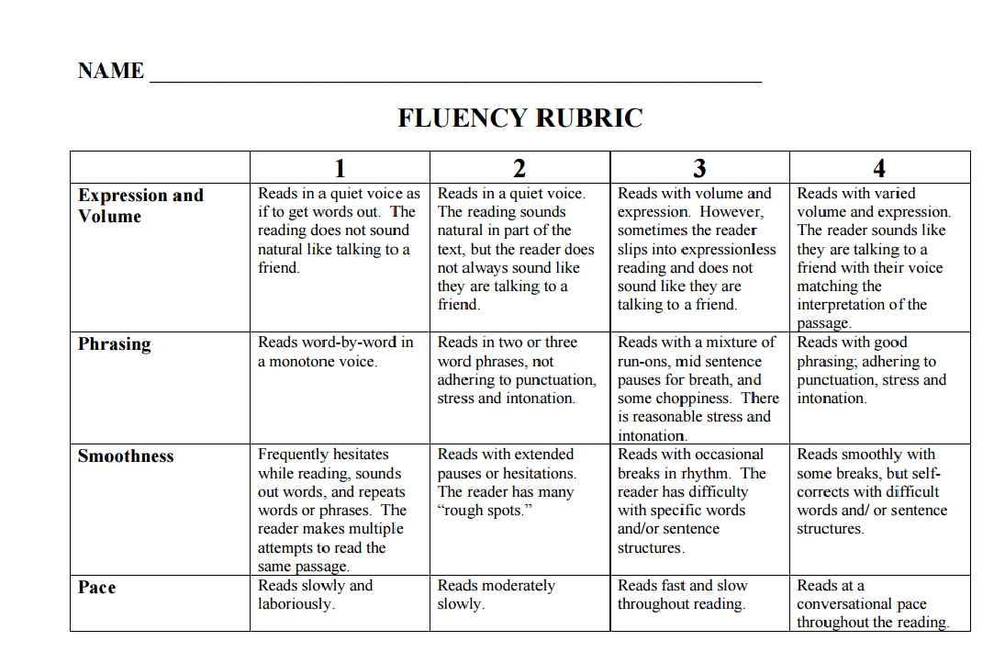

Appendix B

Reading Attitude Survey Sample Page
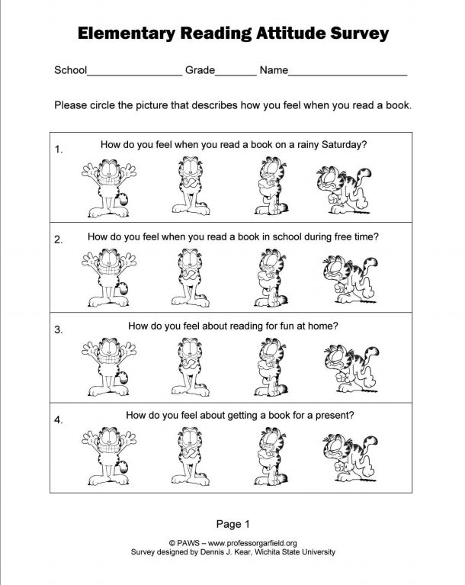
Reading Attitude Survey Scoring Sheet
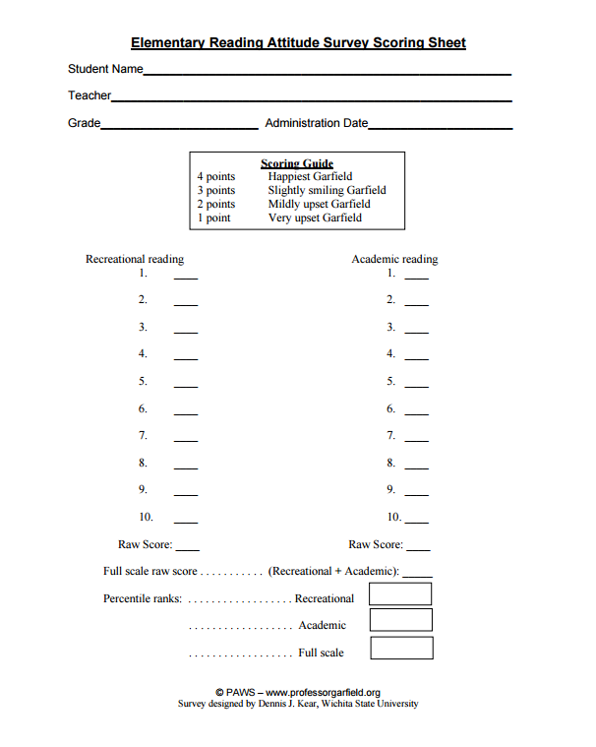

Appendix C
Institutional Review Board Approval Form / Exemption Certificate

Appendix D

Parental Consent Letter

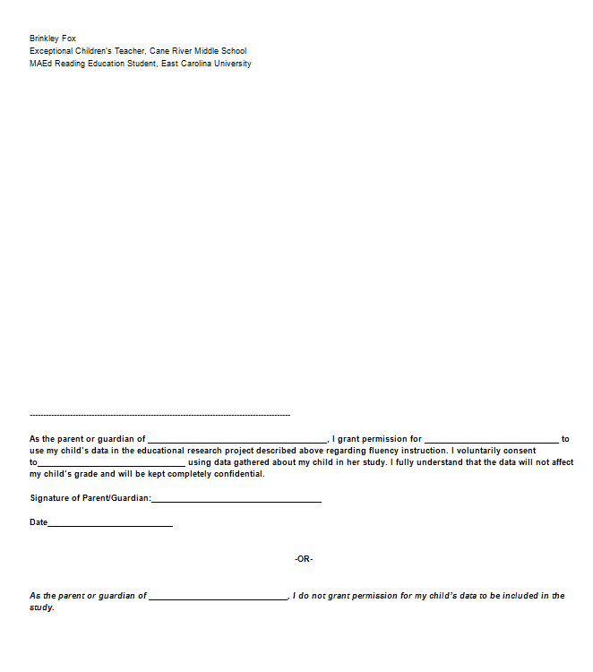

Appendix E

Student Assent Researcher Script and Assent Form

